Notepad Enhanced

Developed by: Brian Ferguson

**What is Notepad Enhanced?**

Notepad Enhanced is a text editor articulated for shear convenience and user efficiency. One of the key factors of the above would be the ability to load multiple documents into separate tabs or a single tab.

N.E may appear to be a word processor with its slick interface and nice feel. But it is really just a power house text editor. Even with its good looks, N.E is still considered a lightweight application. You will never have to worry about it eating your resources.

Some of its features are “new school”, you may not be comfortable with them at first, but in due time, you will get used to them. For instance, the app tries to avoid using popup dialog boxes; many people find these boxes downright disturbing. Most of the preferences will not be in the menu, they will be in a panel that can be shown quickly using the appropriate shortcut key.

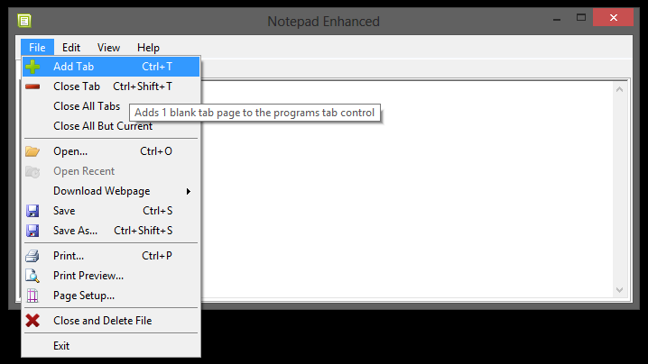

**Features**

**Tab-Control**

C:\Documents and Settings\Brian Ferguson\My Documents\My Pictures\status.png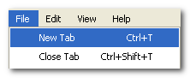The tab Control is where all documents are displayed. Multiple documents can be opened at a time. Therefore by default only one instance off the program will be allowed open. The average computer should be able to open 200 documents with ease (for me its 600 before virtual memory kicks in). The tab control operates like any other tab system. Use the File Menu buttons or shortcut keys to manage the tabs. **Ctrl + T** will add a tab and **Ctrl + Shift + T** will remove a tab. The title of the document loaded in the current tab will be in the caption of said tab (unless you loaded multiply documents into this tab). Your tab count and tab index is displayed on the status bar. The tab count is the amount of tabs currently open. The tab index is the numeric position of the tab currently selected.

You may rename a file using the textbox in the upper right hand corner of the window. It is recommended to leave out the extension. If you rename a file the text on the selected tabpage will change with it. The program may or may not rename the file on disk according to the users preferences. You will also be presented with the save dialog when you do a normal save.

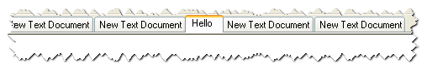

You may use Ctrl + Number key to navigate the tab pages (Ctrl + 1 will navigate to the first open tab, Ctrl + 2 will navigate to the second and so forth).

**Panels**

Instead of using dialog boxes, Notepad Enhanced uses control panels when possible. Dialog boxes float over your work and are annoying. The resolution of the average computer is no longer 800x600. The space saving ways of a popup are no longer needed, panels are the way to go. The panels are implemented in such a way that it will not disturb the working area of the program and will present functionality to the user in the least obstructive manner possible. Notepad Enhanced panels can be opened by clicking a button in the menu or using a shortcut key. The shortcut keys for each panel are listed below.

|  |  |
| --- | --- |
| Panel | Shortcut Key |
| Replace | Ctrl + R |
| Find | Ctrl + F |
| Goto | Ctrl + G |
| Document Info | Ctrl + D |
| About | None |
| Settings | Ctrl + Shift + P |

**Reading View**

The reading view is designed to display the active documents text in a smooth reading environment. The reader view restricts the width to a specific pixel value (great for speed readers). By default the width is set to 800 pixels. You can adjust the reading width in the settings window. The text may appear a bit more squished with horizontal padding applied. If the window is larger than the reading max width, you will see a border. The border color can also be set in the preference panel. You have 3 reading view modes to choose from. The mode depicts the intended use and overall layout of the reading window:

Normal: For quick non-obtrusive reading

Script: For semi- obtrusive reading, like reading a script and recording the upper portion of the screen

Full-Screen: For reading using the entire screen

In script view you can use the bar at the top to adjust the height of the window. You can right click to view the different modes, as well as some preset reading setups. The default setup will be something similar to the “Old Scripture” preset. The “Editor” preset will use the appearance of the editor. There are a handful of hotkeys defined so you can adjust the reading view on the fly:

|  |  |
| --- | --- |
| Key | Action |
| Up Arrow | Move one line up |
| Down Arrow | Move one line down |
| Right Arrow | Go forward a page |
| Left Arrow | Go back a page |
| Page Up | Go to start of text |
| Page down | Go to bottom of text |
| Numpad 4 | Decrease horizontal padding |
| Numpad 6 | Increase horizontal padding |
| Numpad 2 | Decrease vertical padding |
| Numpad 8 | Increase vertical padding |

**Development**

This application was developed by Able Opus. Able Opus, is still a one man army (at the time of this writing). Brian Ferguson is the founder of Able Opus; he created it October 16 2009. Able Opus means “Powered Writer”. Able Opus focuses on releasing free open source software.

Notepad Enhanced was written in the C# programming language. It was created and compiled using the visual studios 2012. It targets the .NET 4.5 Platform. I spent a lot of time debugging this application and I tested it on few different computers.

This is a laid back open source project; I have been working on it alone, on and off for a few years now. If you see any room for improvement feel free to contact me, or join in on the fun.

**Other Things You May Want to Know**

Notepad Enhanced is a single instance app. So the app will make sure you have your documents displaying in one window of tabs, in opposed to separate windows. If you double click on a bunch of files associated with Notepad Enhanced, they will all load up into the same instance of the app. You can disable this by going into the “Preference Panel” and un-checking single instance.

N.E fully supports command line arguments, allowing file type associations and other MSDOS operations to function properly.

I hope this app is a nice alternative to "Windows Notepad", I tried to make text editing with this program in every way smooth.